

Department of Electrical and Electronic Engineering

CPT109 C Programming and Software Engineering 1

CPT109 C Programming Report

Name and ID： Tiankuo.Jiao 1929098

Yuhang.Jiang 1927888

Zhuoyuan.Liu 1927020

Hanbin.Deng 1930239

Shirui.Fan 1928037

Catalogue

1.Specification（Problem statement） 3
1.1 Description of tasks and function 3
1.2 Error analysis and solutions 4
1.2.1 Error 4
1.2.2 Solutions 5
2.Analysis 5
2.1 On an input： 5
2.2 On an output 6
2.2.1 The administrator 6
2.2.2 The worker 6
2.3 Data Structure and Algorithm 7
2.3.1 Data storage 7
2.3.2 Data Assignment and Algorithm 8
3.Design 10
4.Test 14
4.1 For Enter/Exit Worker 14
4.2 For System administrator 18
5.Existing limitations 24
Implementation 24

1.Specification（Problem statement）

  - Description of tasks and functions

The mission is to build a garage management system.

Therefor,the parking space consists of:

1. A 15x15x10 multi-story carpark, where each of the 10 floors is a 15x15 rectangular grid of car parking spaces.
2.An 8x2 rectangular grid of e-bike parking spaces each with an electrical recharge plug is provided.
3.A 10x4 rectangular grid of e-bike parking spaces with no recharge facility (cost should be lower than that for a recharging space).

As a result, there are now two types of users:

For administrators:

1.The administrator shall be able to view, add, delete and modify data, including:

（1）Administrators can add driver information, including:name、university ID number、phone number、account balance and staff or student status.
（2）Administrators can view the above information
（3）Administrators can remove driver information
（4）The administrator can modify the amount in the account (including reducing the amount in the driver's account).

2.The administrator should be able to set the parking fee rate, which is different in each case, including:

（1）the parking fee rate of motor vehicle
（2）the parking fee rate of e-bike without charge
（3）the parking fee rate of e-bike with charge

For parking lot worker:

Check in person who come to park and read their ID number, and read the type of parking they want, including:

(1)Motor vehicle
(2) E-bike without charging
(3) E-bike need to be charged

1.Read the ID number again and ask for charge when the vehicle leaves
2.The staff can release the parking space and read the information of the parking space, including:
(1)The situation of the remaining parking Spaces
(2)The situation of each car

  - Error analysis and solutions

1.2.1 Error

1. Because the program has many choices, there are also a lot of data to fill in. As a result, administrators and garage workers may have entered errors. For example, they should have entered numbers but entered letters.
2. The number entered when setting the the parking fee rate is too large or negative
3. When parking, if the parking space is full, the program may not be recognized

1.2.2 Solutions

1. For each input by administrators and staff, error reporting procedures should be added to prevent user input errors
2. For the parking fee rate, the program requires the administrator to enter only numbers between 0 and 1000
3.If the parking space is full, the program will tell you that the parking space is full

- Analysis：
The mission is to build a garage management system, but the user may enter the digits incorrectly and the user may enter the wrong information causing the program to fail. Therefore, it is necessary to consider how to solve this problem. The error cases mainly include the above points. It is necessary to judge whether the user has entered the correct number and letter.

  - On an input：
Administrators and worker need to input information according to clew which can realize the corresponding function.
The administrator can view and modify the user's information after it is entered. The parking fee rate can be set in the “Set Parking fee Rate” interface. The Credit Driver interface allows you to charge money to your account.
Worker can check in at the garage entrance and check out at the exit. The staff can view the parking space and release the parking space. At the exit, the employee can checkout and collect a fee based on the time the vehicle stops.
  - On an output
In the start screen, the program asks the user whether he is an administrator or a worker

2.2.1 If the administrator is selected, the program will jump to the administrator interface, which contains:

1.add driver information
(1) Id
(2)Name
(3) Phone number
(4) Role(1-staff 2-student)
2.View driver info: All driver information can be viewed
3.Remove driver：After entering the driver Id, the driver information will be removed
4.Credit driver：Administrators can charge money to users
5.Set parking fee rate：The administrator sets the Parking fee rate
6.View parking fee rate：The administrator checks the Parking fee rate
7.Exit

2.2.2 If worker is selected, the program will jump to the Entry/Exit Worker interface, which contains:

1.Check in: When staff members select this option, the system will automatically randomly assign parking spaces
2.view parking space：The staff can check the current parking space
3.check out：End the billing when the vehicle leaves the garage
4.free a parking space：Release the parking space
5.exit

2.3 Data Structure and Algorithm

2.3.1 Data storage

We constructed three structures to store the data.

1.The PARKING_FEE_RATE
2.The PARKING_PLACE
3.The DRIVER_INFO

Structure 1 stored three elements: car-fee rate, ebike-fee rate and ebike-without-charge-fee rate, all with unit pounds/hour.
Structure 2 stored six elements: ‘id’ which record the driver’s id for place management; ‘type’ which record the type of vehicle parked in; ‘state’ which determines the status of the parking place, i.e. if it is occupied; ‘name’ which records the driver’s name for the place occupied by him/her; ‘driver_id’ which is used for place-freeing and ‘time_start’ recorded by function time_t.
Structure 3 stored six elements, which are used for the real storage of the driver’s info in the project requirement: ‘char’ type ‘name’ which is the drivers real name; ‘char’ type ‘id’ which stores the driver’s university ID; ‘char’ type ‘phone’ which stores the driver’s phone number;

All three ‘char’ types were designed for the usage of storing the string variables that represent the real name, ID and phone number. These three kinds of variables will meet a warning statement if not properly entered.
Besides, ‘double’ type ‘balance’ which counts the account balance of the driver; ‘role’ which judges if the driver is a staff or student; This structure also includes structure 2 as a variable, and this nesting is used for recording the parking place of each driver’s vehicle accordingly.

2.3.2 Data Assignment and Algorithm

We used pointers variables to realize the dynamic allocation of addresses and multiple return values of functions.
For example, in function: int get_driver_place( char *driver_id, PARKING_PLACE **p_place),which is used for finding driver’s information of the parking type and position:The pointer variable ‘*driver_id’ will point to the element in structure 2, the double-pointer structure variable ‘**p_place’ will transmit the address of the place of the driver out of this function and thus the outer function can visit ‘PARKING_PLACE’ according to this address, with ‘p_place’ storing the address of the parking place of the driver.
This function when called is in the form of get_driver_place( p_driver->id, &p_place)The -> operation was used for the getting the real driver’s ID in structure 3. In a repeating loop, structure variable ‘p_driver’ was assigned a same address as ‘drivers_info[i]’ after reading through all the registered drivers, meaning that a driver’s information has been fetched, and then the driver’s position stored in the structure variable p_place, specifically, ‘p_place.name’ will be obtained. Due to the pointer variable type of p_place, it should be obtained using ‘->’.
The pointer variable *p_place points to the address of the structure PARKING_PLACE, and in this way the element ‘name’ can be fetched in the function ‘init-system’ so as to obtain the exact position of the driver’s vehicle expressed as ‘Type F-[ ] R-[ ] C-[ ]’ by function ‘sprintf’, which use *p_place, i.e. the address of the structure PARKING_PLACE to receive the value assigned as the position to the element ‘name’, which will be stored in the address using *p_place and be transported and printed in the function view_all_drivers_info().
The basic data operation for printing the parking place is as the figure below:
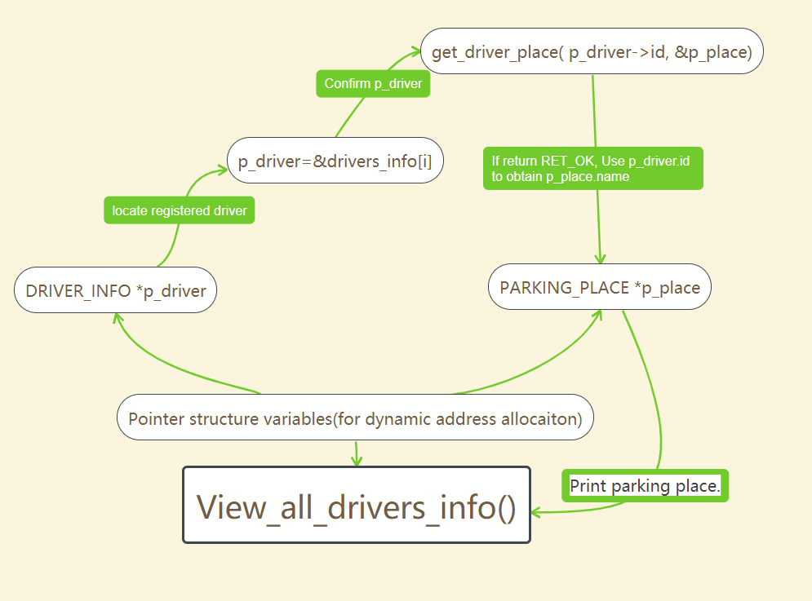

The function get_driver_place can be expressed as:

parking_place[ ]
id
name
driver_id
*p_place
in function get_driver_place() , loop to find the place of driver parked, and return the place address to p_place.

e.g. 0x1000
the variable to store the address being found
The other algorithms and data structures will not be listed explicitly, such as validity judgement and inlet/outlet parameters and menus&execution interfaces switching.

3.Design
1)In the group, we first determined which variable we need to define them as global variables such as the return value of the function and the size number of the parking slot such as the length, the width used in the later programme. Then write the definition before the defined functions.
2)Define a structure called PARKING_FEE_RATE, in order to store the rate of charge for each kind of vehicles. So that the administrator can change the rate of charge and check it.
3)Define a structure called PARKING_PLACE in order to check the state of the parking slots of different kinds of vehicles. Also, the worker can use the information in the structure to check the information of the user who park in the corresponding spot and charge them when they are leaving.
4)Define a structure called DRIVER_INFO which is used to store the name, ID, phone number, account balance and the role of the user.
5)In the main interface we need to provide the user the option of 1. administrator 2.worker and 3. exit We used the switch case to jump to the corresponding interface. If the user type in anything other than 1 to 3, the programme will tell the user that they entered the wrong thing and ask them to enter again.
6)If the user choose 1, then we should provide the user 7 options. 1.add driver information 2.view driver information 3.remove drover information 4. credit driver information 5. set parking fee rate 6. view parking fee rate 7.exit. We used the switch case to jump to the corresponding functions to deal with the problem. If the user type in anything other than 1 to 7, the programme will tell the user that they entered the wrong thing and ask them to enter again.
A.If the user choose 1 we need to ask the ID number, name, phone number and the role of the new user. When entering the role, the user can only enter number 1 staff or 2 student. If the user type in anything other than 1 or 2, the programme will tell the user that they entered the wrong thing and ask them to enter again. If the user is already existed, we need to tell the administrator that the user is already registered. Then the administrator can press any key to continue or press ESC to exit the programme and go back to the main interface.
B.If the administrator choose 2, all the users’ ID number, name, phone number, role balance and the position should be shown. Then the administrator can press any key to continue or press ESC to exit the programme and go back to the main interface.
C.If the administrator choose 3, the administrator should input the ID number of the user he wants to remove. If the ID number do not exist, the programme will tell the administrator that the user does not exist. Then the administrator can press any key to continue or press ESC to exit the programme and go back to the main interface.
D.If the administrator choose 4, the administrator should input the ID number of the user he wants to credit. If the ID number do not exist, the programme will tell the administrator that the user does not exist. Then the administrator can input the amount of money he wants to credit. If the administrator type in anything other than the digital numbers such as a character or a symbol, the programme will tell the administrator they entered the wrong thing. Then the administrator can press any key to continue or press ESC to exit the programme and go back to the main interface.
E.If the administrator press 5, then the administrator need to input the fee rate for cars, e-bike with chargers, e-bike without chargers separately. In group, we discussed the maximum fee rate and determined that the maximum rate should be less than 1000 pounds per hour. Otherwise it would be too unreasonable. So if the administrator type in any number less than 0 or larger than 1000, the programme will tell the user to type in again. Then the administrator can press any key to continue or press ESC to exit the programme and go back to the main interface.
F.If the administrator choose 6, then the fee rate of all kind of vehicle should be shown. Then the administrator can press any key to continue or press ESC to exit the programme and go back to the main interface.
G.If the administrator choose 7, the programme should do back to the main interface.
7)If the user choose 2. we should provide the worker with 5 options:1. check in 2. view parking spaces state 3. check out 4. free a parking space 5.exit If the user type in anything other than 1 to 5, the programme will tell the user that they entered the wrong thing and ask them to enter again.
A.If the worker choose 1, the worker should type in the ID number of the user, then the balance of the account will be shown, then the worker should type in the type of the vehicle 1.car, 2.e-bike without charger 3.e-bike with charger. If the worker type in anything other than number 1 to 4, the programme will tell the user to type in again. Also if the account does not exist the programme will tell the user that the user hasn’t registered yet. Then the worker can press any key to continue or press ESC to exit the programme and go back to the main interface.
B.If the worker choose 2 then all the parking information should be shown including the parking place, driver name and the check in time. The number of occupied slot and empty slot of different kind of vehicles should also be shown.Then the worker can press any key to continue or press ESC to exit the programme and go back to the main interface.
C.If the worker choose 3, the worker should input the ID number of the user who wants to check out. If the user ID is not found the programme should tell the worker that the driver’s information is not found. Then after the check out, the worker should charge the user. The programme should be able to remind the user to pay extra money if their balance is insufficient.
D.If the worker choose 4, then the worker should type in the type of the parking place 1. car,2. e-bike with charger, 3.e-bike without charger. If the worker type in anything other than number 1 to 3, the programme will tell the user to type in again. Also, the worker should type in the specific location of the parking slot to free,such as the floor number, row number and the column number of the car slot. If the worker type in the size number that is larger than the whole parking spot, the programme should tell the worker they entered something wrong.(such as the floor of the parking place should be no more than 10.)
E.If the worker choose 5 the program should go back to the main interface.
8) If the user choose 3,the program should write all the information into the file including: parking fee rate, drivers’ information, the information of all the parking slots including car parking slots and e-bike parking slots. The close the file. Then the whole programme ends.
We can see the logic more clearly from the flow chart below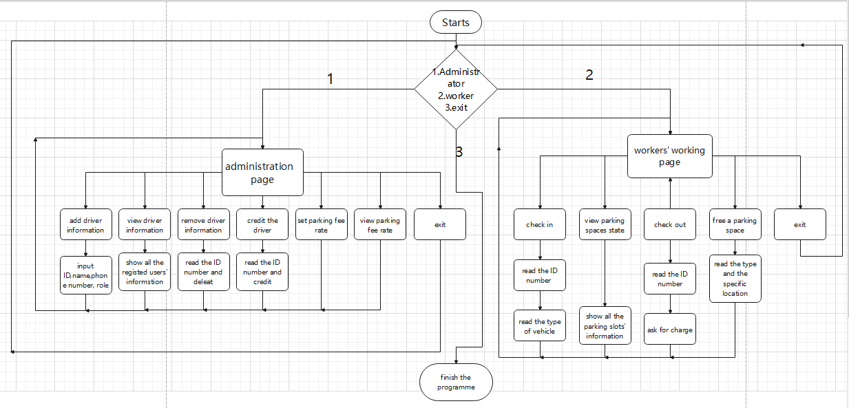
4.Test
4.1 For Enter/Exit Worker
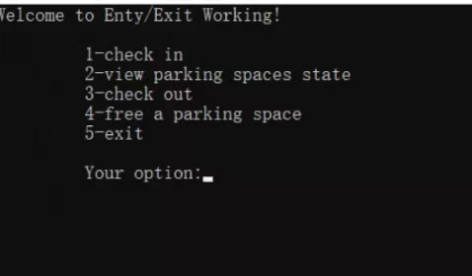
Above is the interface of the entry/exit workers. This test will be divided into two parts. The first one is to test the results when the driver come to park their vehicles. The second one is the result when the worker want to see parking spaces state or free a parking space.

Test 1: Test the check in funtion.
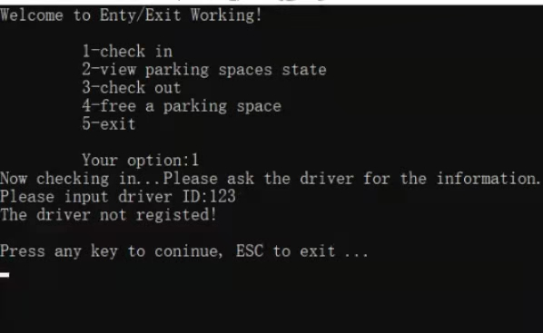
Input 1
Then input the driver's number 123, the result shows above.

Test 2: Test the check out function.
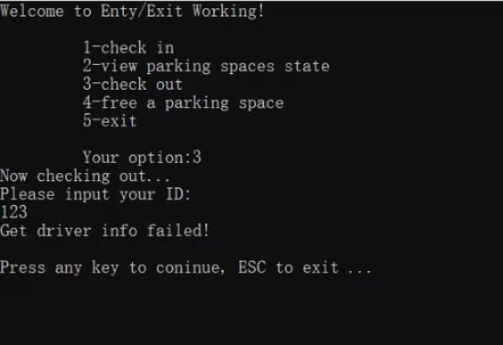
Input 3.
Then input the drivers number 123.The results shows below. When a driver who didn’t check in want to check out, the system will say ‘Get driver info failed’.

Test 3: Test the check in funtion II
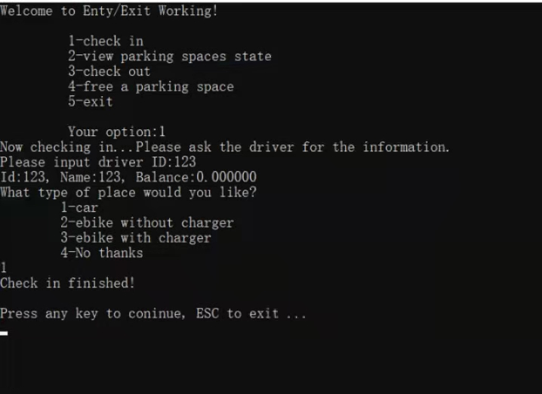
Input The registered driver’s number is 123. The check in process goes well and asks what service the driver want. Input 1,an. The balance of the driver is 0.The results shows above.

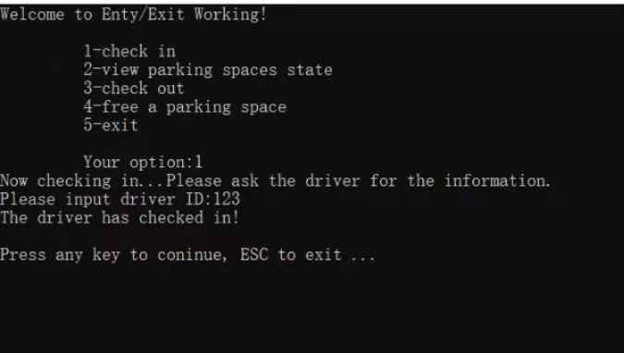
Then we test what will happen when a same number want to check twice.
Input 1.
The result shows above as the system remind the user it is checked in.

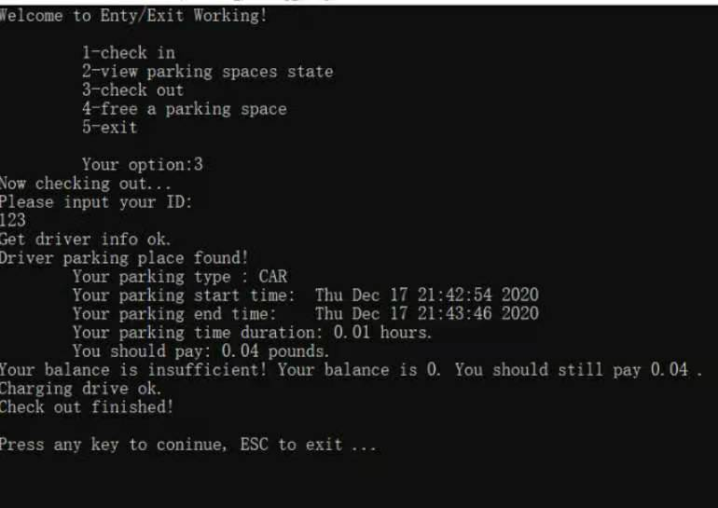
Then we test the result when the driver wants to leave.
Input 3.
The system provides information including the parking type, start time, end time, duration and the total money he need to pay. Since the balance is zero, the driver needs to pay another 0.04 pounds.

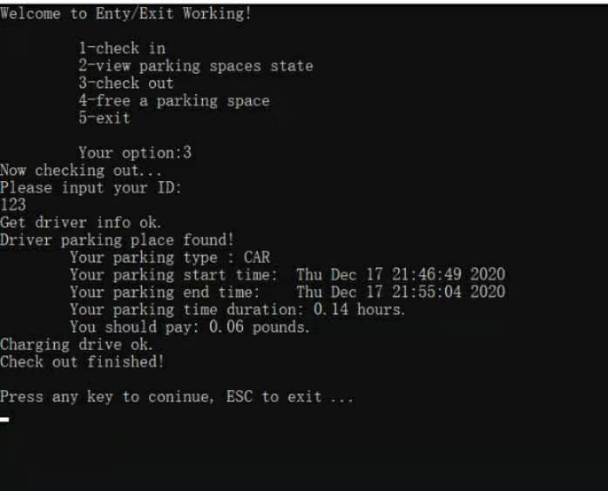
Input 3.
The picture above shows the results when the driver 123 has enough money in his balance to pay the fee.

Test 4: To test the functions for the workers
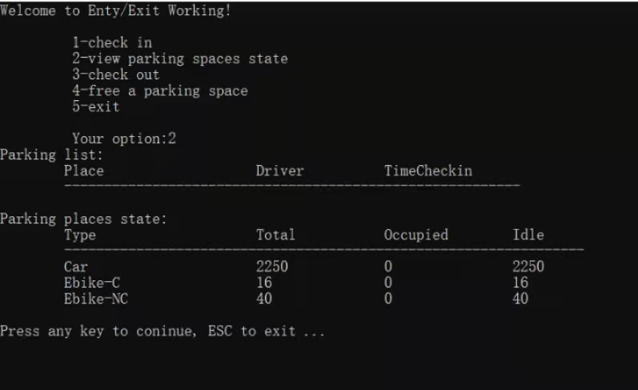
We input 2 . The system records the parking place, driver number, time. In addition, the parking places state information are also included in the system. They are total number, occupied number and idle number.

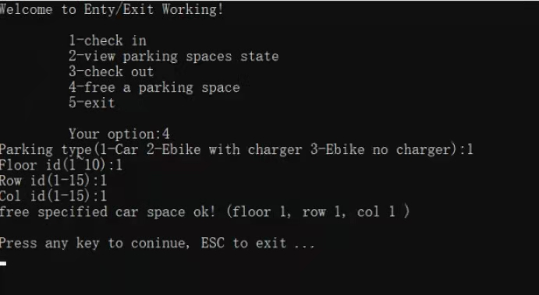
Next, we test the result when the worker wants to free a parking space. We input F1 Row1 Col1. The result shows in the figure above that we successfully free a parking space.

4.2 System administrator
Test 1:Test administrator to add and view parking space information
Enter 1 in the administrator interface to add vehicle information
Input ID number 1, name a, phone number 12345678900,role number 1, the customer information is added successfully
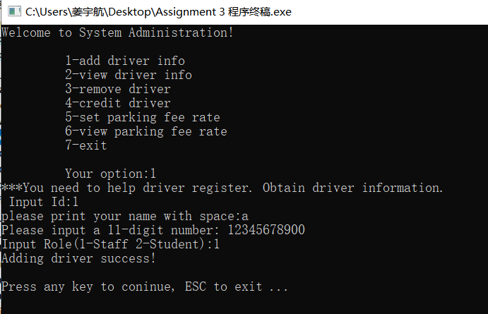

Test 2
Input the name with a number in it or Input the name with only space
The programme will tell the uses they entered the wrong thing and tell them to enter again.
Test 3
Input the phone number with characters, symbols, more or less than 11 digit numbers
The programme will tell the uses they entered the wrong thing and tell them to enter again.
Teat 4
In put the role number with anything other than number 1 or 2.
The programme will tell the uses they entered the wrong thing and tell them to enter again.
Test 5
If the administrator tries to add a driver account that is already exist,the programme will tell the administrator that the driver is already existed.
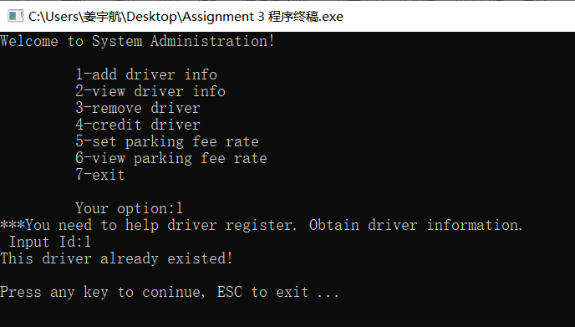
Test 6
Continue to input 2, you can view the vehicle information just added
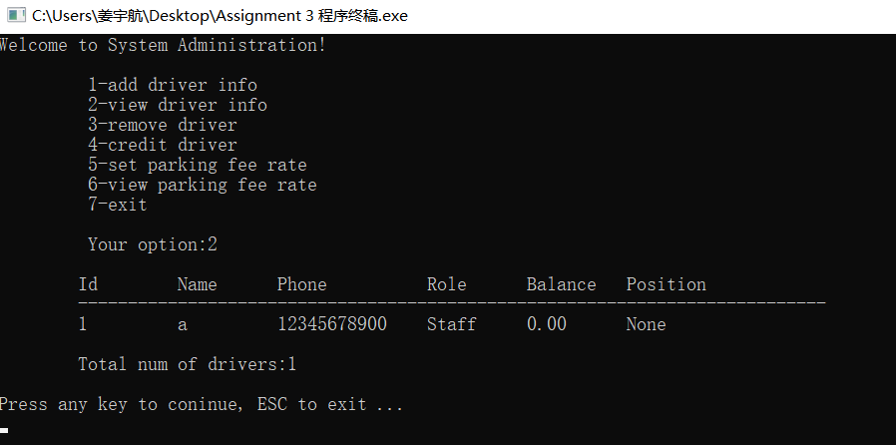

Test 7: Recharge parking fee to customer's vehicle information
Construction recharge amount is 1, continue the program, can recharge successfully
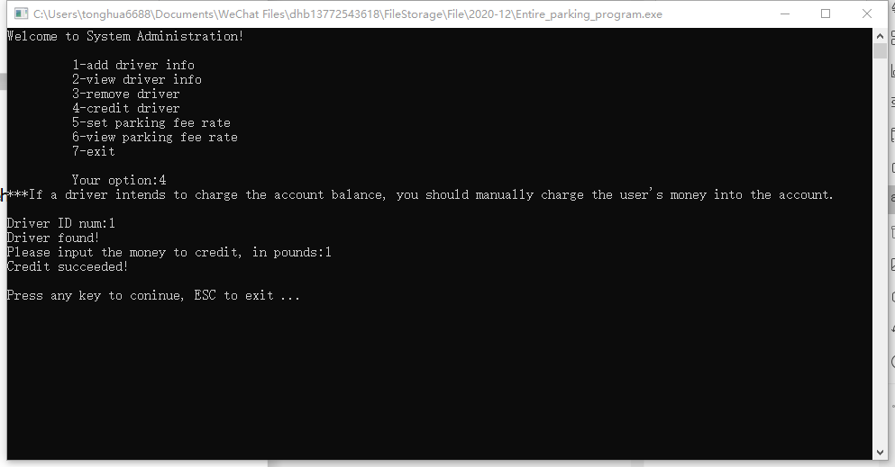
In put the recharge amount is a or \.
The programme will tell the uses they entered the wrong thing and tell them to enter again.

Test 8: Remove vehicle information
After selecting 3
The information of account 1 is successfully removed
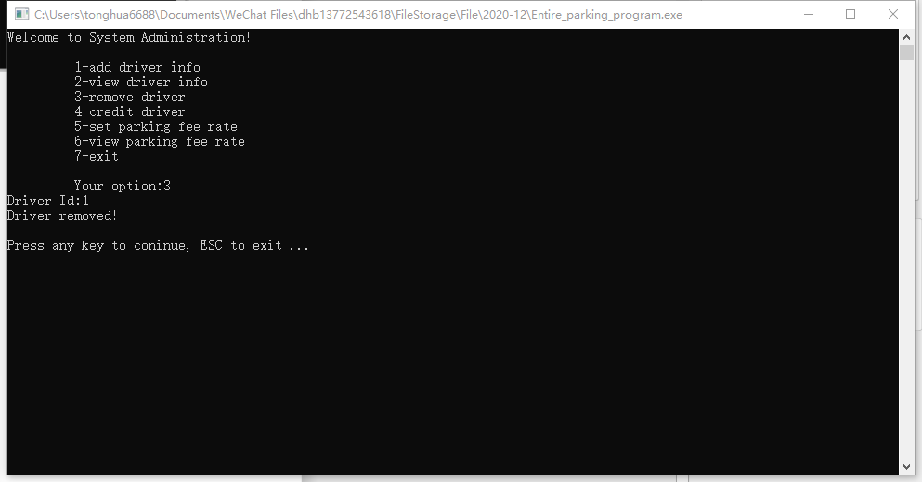

Test 9: Remove other information
In put the information with a
The removal is successful

In put the information with A1 information
the removal is successful

In put the information with . information
the removal is successful

In put an information that has not been entered,
it will be displayed that no information has been non-existent

Test 10: Set up and view parking price

In put the car place fee rate, e-bike place with charger fee rate and e-bike place without charger fee rate all are 1.
The parking price is set successfully after continuing to input
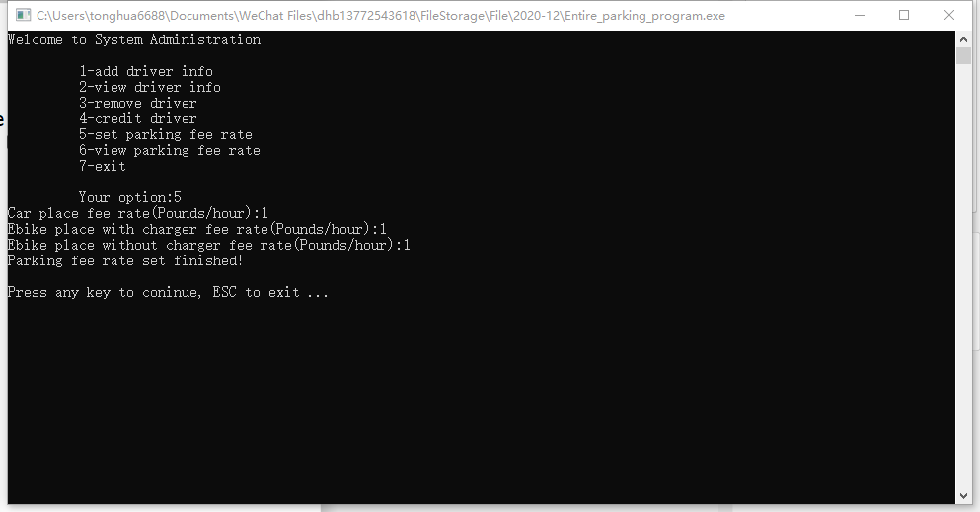

Continue the program,
Input 6,
You can view the price of all parking spaces just set
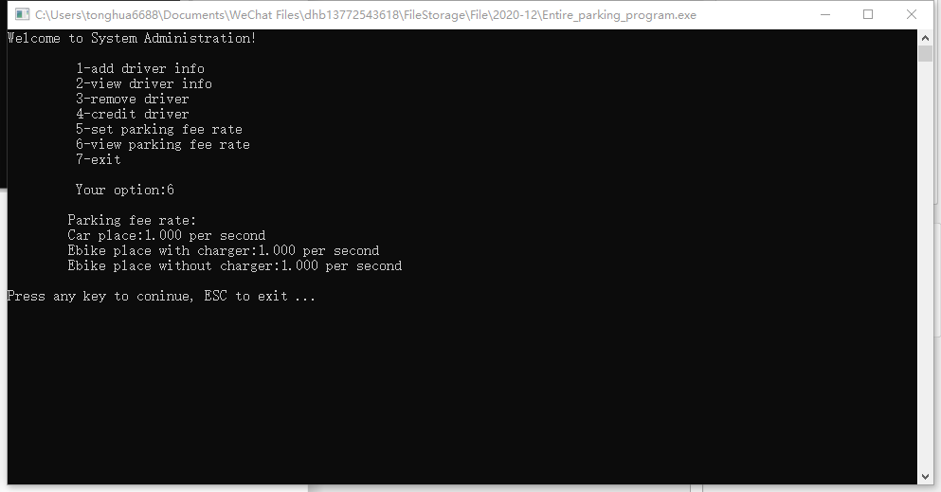

In put the parking amount is a
the program crashes

In put the parking amount is \
the program crashes

In put the parking space amount is nothing
The check parking space amount will be displayed as 0, but the program runs normally

Test 11:Back to main page

After entering 7 successfully, return to the main page
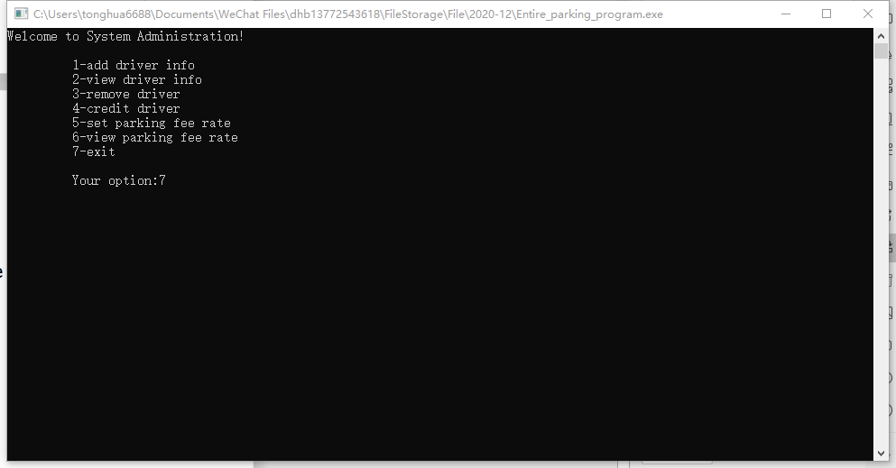
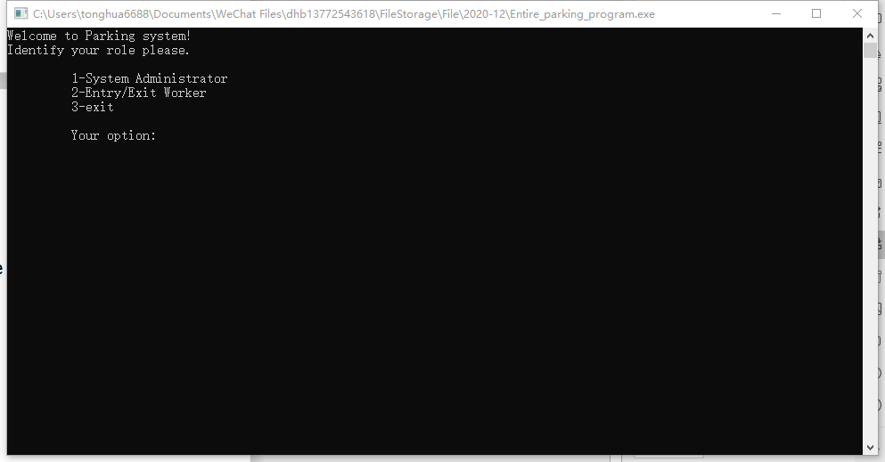

- Existing limitations
Files can only be saved after users exit program. Some users may exit at will, which may result in files in the program being unable to be saved.
Implementation
Group 38 The garage management.c

